1. Graphical user interface, text, application

   Description automatically generated
2. Text

   Description automatically generated
3. 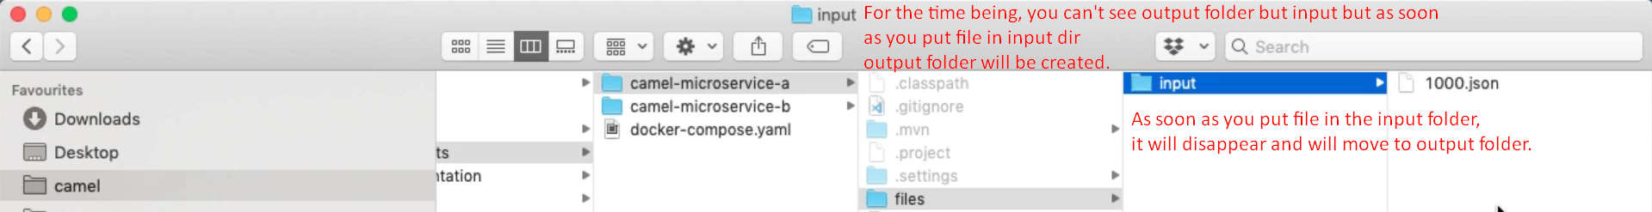
4. 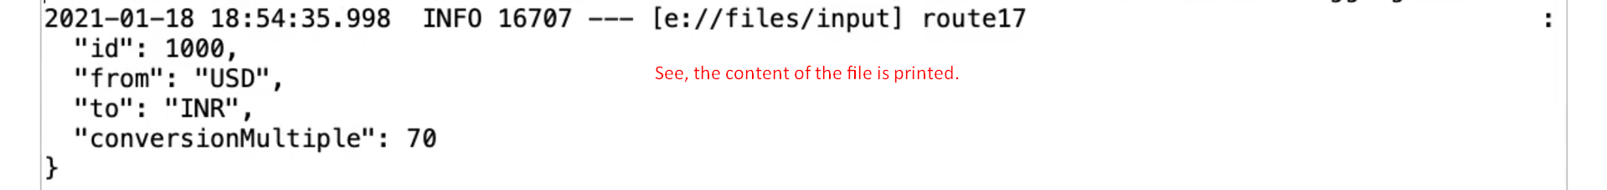
5. Note that with just 3 lines, we can achieve this logic. 😊